指标数据采集与存储
Gathering and storing the index data

指标（index）
指标最重要的特性有二：采样频率（最高1Hz）、采样精度（每个样本的大小）。其中采样精度不会改变，但采样频率可能会改变。
The most two important specifications of index are: the sampling rate (max 1Hz), the sampling precision (sample size). The first one maybe change, but the second one will never change.
目前确定的指标有：
Current definite indexes are:
- HR：2字节，前一字节为HR的数值，后一个字节表示HR数据的可靠度，其中最高位表示设备是否佩戴，1=佩戴；0=未佩戴；
HR: two bytes, first byte is the value of HR, second byte is the reliability of the value. The MSB means whether the device is worn or not.
- ECG：2字节；
ECG: two bytes
- Ambient Temperature：2字节。一个字节为整数部分，一个字节为小数部分，精确到小数点后一位；
Ambient Temperature: two bytes. One for the integer of the value, the other one for the decimal of the value. Accurate to one decimal point.
- Skin Temperature： 2字节。一个字节为整数部分，一个字节为小数部分，精确到小数点后一位；
Skin Temperature: two bytes. One for the integer of the value, the other one for the decimal of the value. Accurate to one decimal point.
- Accelerator: 2字节。为加速计矢量（三轴矢量和）的模；
Accelerator: two bytes. The vectors sum of the accelerator.
- Steps：计步数。可从Accelerator计算出来；
Steps: steps value. Calculated from the Accelerator
- Calorie consumption：卡路里消耗。可从Accelerator计算出来；
Calories consumption: Calculated from the Accelerator
- UV：1字节；
UV: one byte.

数据存储方案(data storing solution)
采集到的指标数据，将存储在外部Flash中。
The index data will be stored at the external flash

Flash存储特性(flash storing specification)
在存储、修改任何数据之前，需对Flash进行擦除。Flash擦除操作按page进行，每个Flash芯片的Page Size可能不同。
The erase operation is necessary before any data storing and modifying operation. The erase operation is only took place on page of flash. The page size of flash IC may be not the same.
目前所用的Flash芯片
The flash IC is currently used
如需修改Flash的内容，需将现有内容读取至RAM进行修改，擦除Flash后再将数据回写。
If needing modify the content of the flash, must read the content to RAM, then modify, then erase the flash ,finally write the content modified to flash.

Flash存储策略(flash storing strategy)
在每个Flash Page前，预留若干个字节做为检索标记。
A few bytes are needed for index marking at each flash page.
#define FLASH_SECTOR_TAG (0xB38F0CB9)

typedef struct _FLASH_SECTOR_HEAD
{
INT32 tag; // 应该等于FLASH_SECTOR_TAG
INT32 index; // 递增的存储序号
time_t startTimestamp; // gmt时间戳
time_t endTimestamp; // gmt时间戳
INT16 chunkSize; // chunk的大小
BYTE schemaVersion; //
BYTE reserved[13]; // 保留若干字节用于后续扩展，目前整个结构共计32个字节
} FLASH_SECTOR_HEAD;

- 4个字节的固定标志： 0xB38F0CB9，有此标志的page已格式化
Definite marker (four bytes): 0xB38F0CB9, If the marker exists, that means the page is formatted before.
- 4个字节的存储索引号：从1开始编号，递增；全FF都表示Page未使用。存储索引号简称为“索引”；
Storing index number (four bytes): starting from 1, increasing by 1. If the index number is totally FF, that means the page will not be used before. Index is short for the storing index number.
- 4bytes：起始时间戳
Four bytes: start timestamp
- 4bytes：结束时间戳
Four bytes: end timestamp

注意，索引是对Page的编号，某个Page的索引在下次存储时可能会修改为新的值。
Notice, the index is just for the page number, it will may be updated when it be accessed in the future.
在RAM中保存当前索引和状态，可加快Page查找。
The current index and status are saved at RAM, which can accelerate the page looking for.
在系统重启时，需扫描所有Page，重建当前索引和状态。
When reboot, all of page will be scanned, the current index and status will be reconstructed.

Page选择机制(page choosing mechanism)
系统初始化时，所有Page都被擦除，即索引均为全FF，状态为FF。
All of pages will be erased, that means all the index of page and status will be FF, when system is initialized.
存储第一块数据时，Page的索引存储为1。
The index of page will be the 1, when the first chunk data are saved.
每次需要使用新的Page时，查找到下一个未使用的Page即可。
Needing use the new page, Look for one page not used
若所有的Page均已被使用过（索引不为全FF）且状态为2（已满），则选择索引为最小的Page，重复使用。
If all of pages are used (index of pages is not entirely FF) and the status is 2 (completed), the page has the minimum index can be reused.
若Page的状态为1，则说明还有空间可供继续存储，应当遍历此Page，直到找到可用空间，并继续使用。参考指标数据存储布局。
If the status of the Page is 1, that means there is some space unused. Check the whole page for unused space. Refer to the index data storing layout.

指标数据存储布局(index data storing layout)
采集的指标数据先缓冲在RAM中，待存储条件满足后，才写入到Flash。
The index data firstly buffer at the RAM, when requirement met, they are written to flash.
每次存储的数据称为一“块chunk”。
The each buffered index data is referred as a “chunk”.
一个chunk的大小固定为508个字节，将一个sector分为8个chunk（除去32个字节的sector head）。
Every chunk has definite 508 bytes. One sector of the flash can be divided into 8 chunks (sector head occupied 32 bytes).

每次写入的指标数据种类可能不同，其布局为：
Every time the category of index data may be different, its layout is following:
- 时间戳：4字节
Timestamp: four bytes
- 指标数据种类数：1字节
The categories of index data: one byte

- 第一种数据存储：
The first category index data storing:
- 数据类型：1字节
Category of index: one byte
- 采样周期：2字节，按秒计
Sampling period: two bytes, the unit is second
- 样本数量：2字节
Sample size: two bytes
- 数据。不同种类的数据，样本大小（精度）不一，参看指标说明
Data . Different categories data, different sample size (sample precision). Refer to index .
- 第二种数据存储
The second category index data storing
1~3结构如下：
The structure of 1 to 3
typedef struct _FLASH_DATA_CHUNK_HEAD
{
time_t timestamp; // gmt时间戳
BYTE channels;
int16_t timezoneOffset; // 数据记录时所在的时区偏移，以分钟计
BYTE reserved[9]; // 保留若干字节用于后续扩展，目前整个结构共计16个字节
} FLASH_DATA_CHUNK_HEAD;

4的头（4.1~4.3）结构如下：
The structure of head of 4.1 to 4.3
typedef struct _INDEX_DATA_HEAD
{
BYTE type; // 数据类型
INT16 interval; // 采样周期
INT16 samples; // 样本数量；sampleSize没有描述信息，只有文档记录
INT16 offset; // 数据偏移，相对于chunk
} INDEX_DATA_HEAD;

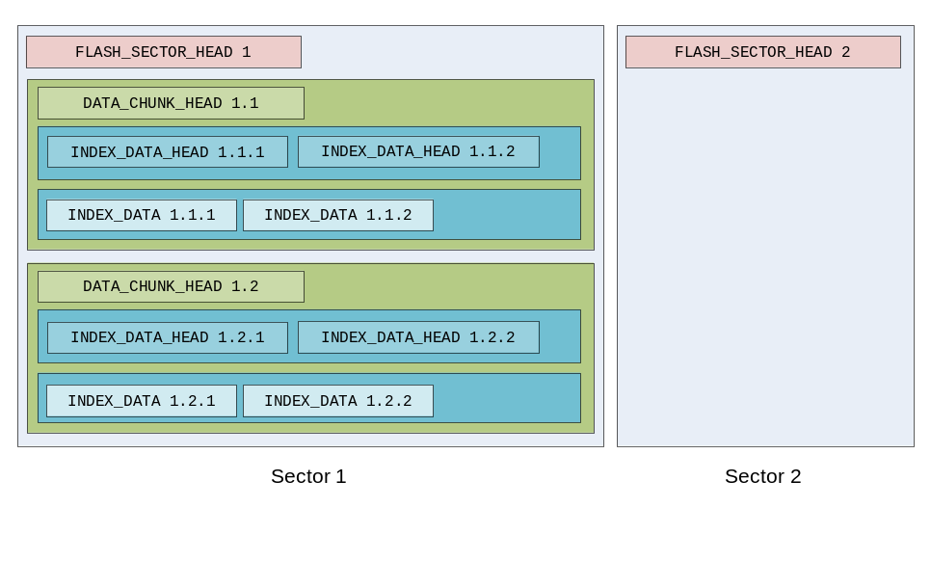
可知：每次数据存储都以时间戳开头(4字节)，后接一个字节的指标数(1字节)；2字节数据大小；然后是第一个指标的存储头（类型、采样频率、samples，共5字节）
The index data storing begin with timestamp (four bytes), one index data (one byte) is following, then two bytes sample size; The head of first index data which includes category, sample rate, samples ,totally five bytes is following.

// 所有的数据种类
typedef enum _INDEX_DATA_TYPE
{
DATATYPE_UNKNOWN = 0,
DATATYPE_HEART_RATE = 1,
DATATYPE_ECG,
DATATYPE_ECG_VAL,
DATATYPE_AMBIENT_TEMPERATURE,
DATATYPE_SKIN_TEMPERATURE,
DATATYPE_ACTIVE_LEVEL,
DATATYPE_STEPS,
DATATYPE_DISTANCE,
DATATYPE_CALORIE_CONSUMPTION,
DATATYPE_UV,
DATATYPE_IR_REG,
} INDEX_DATA_TYPE;

typedef struct
{
INDEX_DATA_TYPE type;
bool accumulative; // 指标是否是累加指标，比如计步，保存时只保存增量
BYTE sampleSize;
BYTE sampleInterval;

BYTE* data;
BYTE* lastData;

int weight;
} INDEX_DATA_DEF;

static INDEX_DATA_DEF DATA_DEF_HEART_RATE =
{
DATATYPE_HEART_RATE,
false,
2,
5,
};

static INDEX_DATA_DEF DATA_DEF_ECG =
{
DATATYPE_ECG,
false,
2,
1
};

static INDEX_DATA_DEF DATA_DEF_ECG_VAL =
{
DATATYPE_ECG_VAL,
false,
2,
1
};

static INDEX_DATA_DEF DATA_DEF_AMBIENT_TEMPERATURE =
{
DATATYPE_AMBIENT_TEMPERATURE,
false,
2,
60,
};

static INDEX_DATA_DEF DATA_DEF_SKIN_TEMPERATURE =
{
DATATYPE_SKIN_TEMPERATURE,
false,
2,
60,
};

static INDEX_DATA_DEF DATA_DEF_ACTIVE_LEVEL =
{
DATATYPE_ACTIVE_LEVEL,
true,
2,
60,
};

static INDEX_DATA_DEF DATA_DEF_STEPS =
{
DATATYPE_STEPS,
true,
2,
60,
};

static INDEX_DATA_DEF DATA_DEF_DISTANCE =
{
DATATYPE_DISTANCE,
true,
2,
60,
};

static INDEX_DATA_DEF DATA_DEF_CALORIE_CONSUMPTION =
{
DATATYPE_CALORIE_CONSUMPTION,
true,
2,
60,
};

static INDEX_DATA_DEF DATA_DEF_IR_REG =
{
DATATYPE_IR_REG,
false,
2,
2
};

static INDEX_DATA_DEF DATA_DEF_UV =
{
DATATYPE_UV,
false,
1,
60,
};

内存存储布局(RAM storing layout)
- 限制指标数据总的内存存储空间，比如1K。
Limit the size of index data storing, such as 1 kilo bytes
- 启动数据采集前，需确定：采集哪几种指标，及每种指标的采集频率。
Which categories and what sample rate should be explicit before start gathering index data.
- 然后估算每种指标所占空间的比例，估算方法？
Estimate how much space should be used for every index data. estimate algorithm ?
- 为每种指标分配独立的缓冲区；
Allocate the independent buffer for every index data
- 开始采集数据；
Start gathering
- 若存储条件满足，则启动Flash写入程序，将内存中的指标数据写入Flash。
When requirement met, start the flash writing program, write the index data from buffer to flash.

存储布局为：
Storing layout:
时间戳
timestamp
指标列表
List of index data
类别
Category
采样频率
Sample rate
缓冲区大小
Buffer size
缓冲区指针
The pointer for buffer

缓冲区大小估算方法(algorithm for estimating buffer size)
为每个指标计算存储权重，然后根据权重记得每个指标缓冲区的大小
Calculate the weight of every index data, calculate the size of buffer every index data needs, according to its weight.

存储触发条件(storing trigger)
内存中的数据，写入Flash的触发条件有二：
The conditions for writing the index data from buffer to flash:
- 指标数据缓冲区满
There is no space for saving other data
- 采集停止
Gathering stops

数据上传(uploading data)

流程(flow)
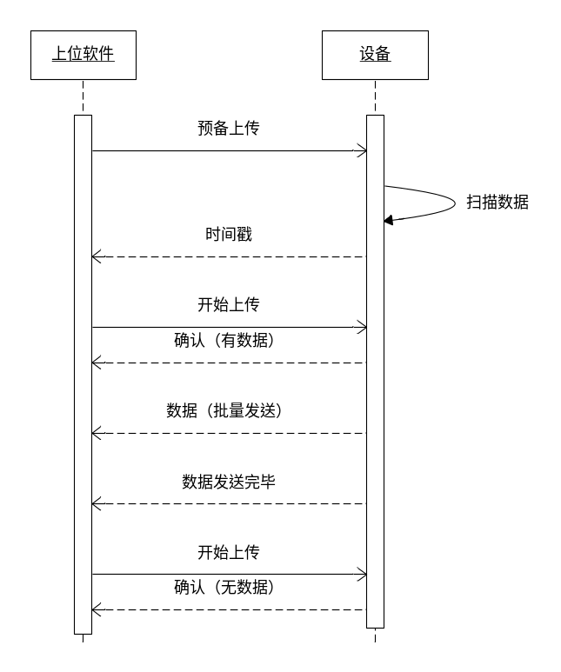

指令集(instructions sets)

预备上传(prepare uploading)
由客户端通知设备预备数据上传操作。设备应该扫描sector，找到包含起始时间戳的sector，并答复给客户端。
Client informs device preparing uploading data. Device should scan sectors, find the sector which has start timestamp and reply to the client.

格式：0x50, 起始时间戳(4bytes), mode(1byte), dumpMode(1byte)
Format: 0x50, start timestamp (four bytes), mode(one byte)
dumpMode(one byte)
mode: 0x00-normal;0x01-low speed mode
dumpMode: 忽略所有有效性检查，直接下载数据。0x00 = false; 0x01 = true;
dumpMode: ignore all validity check, upload data directly.

响应：
Response:
0x50, sector编号(2bytes), timestamp(4bytes),result(1byte),totalSector(2bytes)
0x50, sector number(2bytes), timestamp(4bytes),result(1byte),totalSector(2bytes)

result: 0=success, 0xf0=out of battery
sector:0xFFFF=没有找到符合条件的数据
If sector is equal to 0xFFFF, that means there is no valid data.
totalSector: 仅dump模式可用，表明总的sector数据
totalSector : Only dump mode , that means the whole sectors

开始上传(start uploading)
由客户端通知设备开始数据上传操作。
Client informs the device starting uploading data.
格式：0x51, sector编号(2bytes)。
Format :0x51, sector number (two bytes)
sector：0xFFFF=上传下一块；0xFFFE=重新上传；其他=上传指定sector数据
when sector is equal to 0xFFFF, that means upload the next chunk;
when sector is equal to 0xFFFE, that means upload the chunk again;
when sector is equal to others, that means upload the data of the definite sector;

响应：0x51,result(1byte), sector编号(2bytes) , startTimestamp(4bytes) , endTimestamp(4bytes)。
Response: 0x51,result(1byte), sector number(2bytes) , startTimestamp(four bytes) , endTimestamp(four bytes)。
result:0x01=确认操作；
when result is equal to 0x01, that means verify the operation
0x02=sector tag 无效（未格式化的sector?）；
0x02,that means sector tag is invalid(maybe not formatted the sector)
0x03=sector参数错误；
0x03,that means the parameter is not accuracy
0x04=flash操作错误；
0x04,that means flash operation fails
0x05=sector index小于上一个sector的index
0x05,that means the current sector index is smaller than the last one
0x06=时间戳为缺省时间戳（已格式化，未写入数据）
0x06,that means the timestamp is the default one.(formatted ,no data has been written into)
0xf0=dump操作完成
0xf0,that means dump operation complete.
其他=错误代码
Rests , that means error happens.
sector：当前正在处理的sector
sector: indicate the current using sector
startTimestamp：当前sector起始时间戳
startTimestamp: the start timestamp of current sector
endTimestamp：当前sector结束时间戳
endTimestamp: the end timestamp of current sector

批量上传完毕通知(inform batch uploading completely)
设备通知客户端，一批数据已上传完毕
The Device informs the client that one batch data has uploaded completely.
需要做超时处理，即限制一批数据的上传时间
Overtime is needed, that is, limit the time for the batch data uploading

格式：0x52,sector编号,数据CRC（2bytes）
Format: 0x52, sector number, crc validation of the data (two bytes)
响应：无
Response: none

结束上传(end uploading)
客户端通知设备，上传操作结束。
The Client informs the device that the uploading has completed.
格式：0x53
Format: 0x53
响应：0x53, 0x01

Response: 0x53,0x01

客户端 设备

1、准备上传(0x50,timestamp)
1.1停止所有flash操作（包括数据采集）
1.2扫描flash，查找包含timestamp的sector
1.3如果找到，记录sector，并响应(0x50,sector)
1.4如果未找到，响应(0x50,0xffff)

2、要求上传(0x51)
2.1如果还有数据待上传，响应(0x51,0x01,待上传sector编号)
2.2如果数据全部上传完毕，响应(0x51,0x02)

2.3上传一批数据，不握手

2.4数据上传完毕后，发送通知(0x52)

3、检查数据正确性，决定继续上传还是重传，回到步骤2

4、结束上传(0x53)
4.1响应(0x53,0x01)

client device

1、prepare uploading(0x50,timestamp)
1.1stop any operation for flash (gathering data is included)
1.2scan all sectors, look for one sector with specified timestamp
1.3If found, record the sector and response with (0x50,sector)
1.4If not found, response with(0x50,0xffff)

2、require uploading(0x51)
2.1If there are data needing upload，response with(0x51,0x01, sector number)
2.2If there is no data needing upload，response with(0x51,0x02)

2.3upload a batch data，without shaking hands

2.4finish uploading，send information(0x52)

3、check the validity, decide to continue to upload or repeat upload

4、stop uploading(0x53)
4.1response with(0x53,0x01)

